Cheetah Conservation Fund Namibia Visit (September 8-13, 2025)
Our visit to the Cheetah Conservation Fund (CCF) in Namibia was both informative and enjoyable. It provided an opportunity to reconnect with long-time acquaintances and meet new team members. The visit highlighted the behind-the-scenes work that supports various programs funded by donors, including genetics and ecology. Despite the absence of Laurie (she had left a few days earlier for a major IUCN meeting in Poland and then on the US fall tour), a full schedule of meetings and experiences was prepared. In-depth interactions with various department teams provided us clarity on how CCF Canada can continue to support key programs.
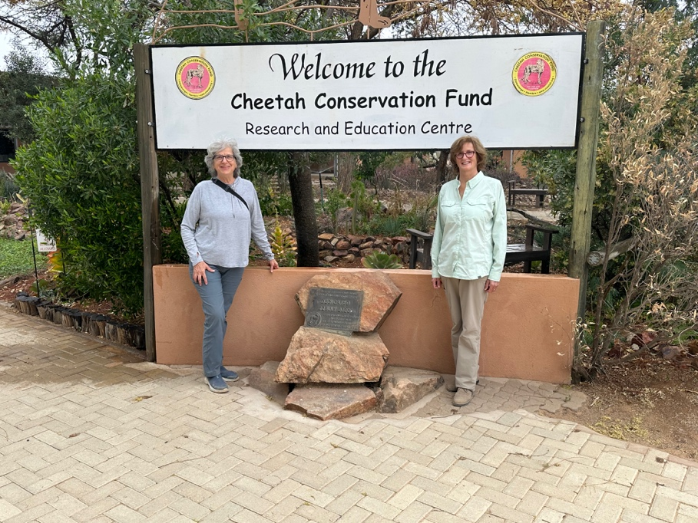

We received a warm welcome from everyone as representatives of CCF Canada. Many people were already aware of the support we have provided, and Marie-Claude emphasized our contributions by noting that we have provided around C$1.5 million over the past decade.
One of our goals was to better understand the specific needs of each team, whether it be equipment (e.g., tracking collars, diagnostic tools), support for field research, or other areas. This understanding will help us approach potential funders in Canada and collaborate with CCF and other affiliates.
We spent in-depth time with all the department teams, including those in direct contact with visitors to the Centre and those providing research and scientific expertise. Shadowing their work and asking detailed questions helped us see how all the programs fit together and provided clarity on how CCF Canada can continue to support CCF’s key programs. It was noticeable that the calibre of staff members has strengthened since my last visit in 2015 and 2016, and there are now more Namibian staff members.
One of the newest staff members is a Canadian – Kayla Schmitz, a former intern who learned about CCF from Becky Johnston. Her parents were visiting her and currently live in Calgary. They were very engaged in learning about the work of CCF.
We also had the opportunity to see firsthand some of the initiatives funded by our Canadian donors, especially those supported by the Gray Family Foundation, Koval Foundation, and B2Gold/Clive Johnson. These projects include animal (cheetah) pens, staff housing, lab equipment and a multi-unit building for staff accommodation, called Canada House.
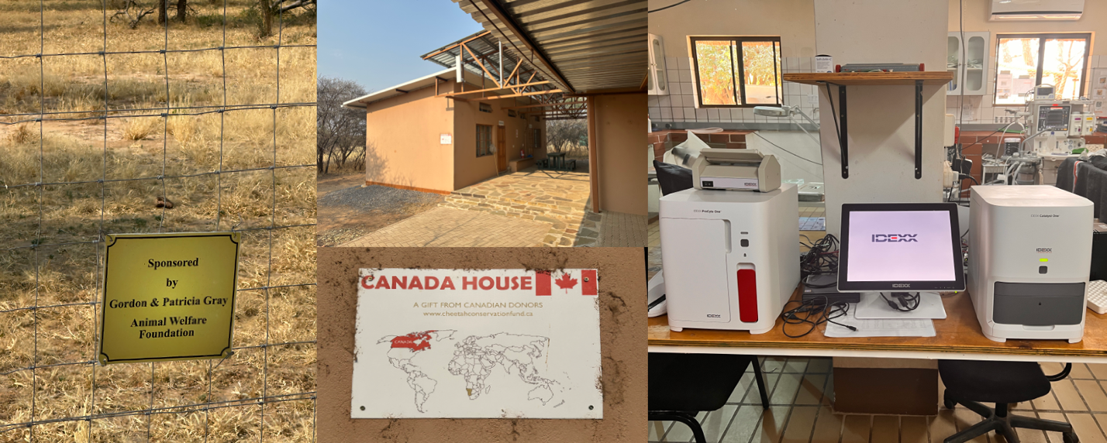

We met with the manager directly involved with the Student Intern program (specifically on the Vanier program) to discuss the work to date of the students from Environmental and Wildlife Management and Animal Health Technology. In the coming academic year, two AHT teachers will visit CCF in October, and six students will visit in March 2026.

Highlights of our Visit

Livestock Guarding Dogs and Model Farm
Calum O’Flaherty leads the Livestock Guarding Dog (LGD) Program and manages the team responsible for the care of the dogs, their puppies, the goats, and sheep. He works closely with farmers to ensure the program's success. Calum provided us with a comprehensive tour of the team’s activities, highlighting the key components of training the dog and include:
- Basic Obedience & Socialization
  - Teaching pups to respond to commands like sit, stay, and leave.
  - Socializing with humans, livestock, and other animals to ensure calm and non-aggressive behavior.
- Bonding & Trust Building
  - Spending time with the pups to build a strong bond and ensure they are comfortable around people and livestock.
- Pre-Release Behavior Training
  - Introducing the dogs to livestock and teaching them to guard without harming animals.
  - Training to ignore distractions and focus on their herd.
- Protection & Patrolling Skills
  - Developing alertness and territorial behaviors.
  - Teaching the dogs to patrol boundaries and respond to threats.
- Environmental Familiarization
  - Exposing dogs to the local terrain, vegetation, and potential threats.
- Communication & Responding to Commands in the Field
  - Training to respond reliably to commands such as recall, leave, or attack, especially in outdoor or noisy environments.
- Health & Nutritional Management
  - Ensuring dogs are in good health, vaccinated, and well-fed before placement.
- Ongoing Monitoring & Support
  - Providing training support and refresher sessions after deployment to farmers.
One notable initiative is the Snake Aversion Training Program, developed in response to fatal snake bites – a leading cause for the loss of dogs. The results of this program are promising. We met almost all the dogs on site and experienced their gentle personalities and rigorous training. One of the dogs we met was Nahanni, a female named through our Canada-based naming contest.
We were at the model farm during the kidding season and observed newborn kids. After five days, they are taken outdoors with the goats and other kids.
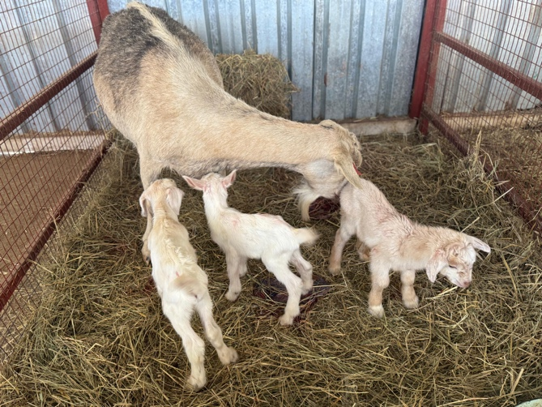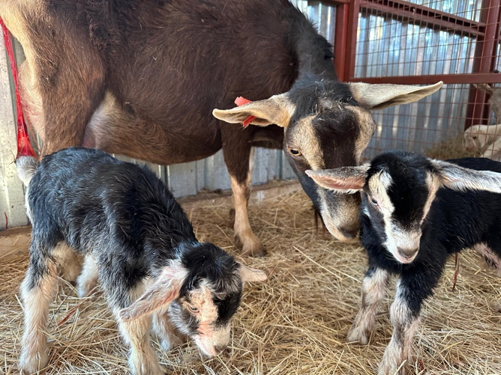

CCF has continued to expand the Dancing Goat Creamery products, including several cheeses, ice cream, and soap. We met Heita, one of the staff leads at the creamery, who holds a degree in Food Science from the University of Namibia.
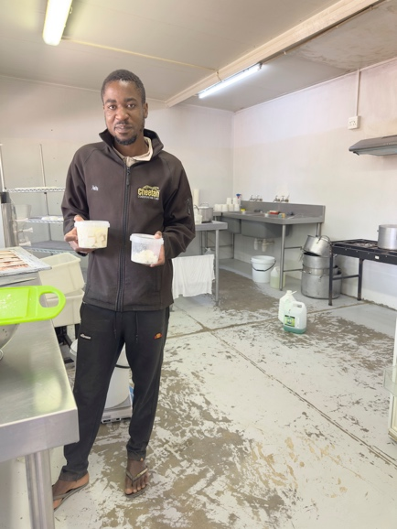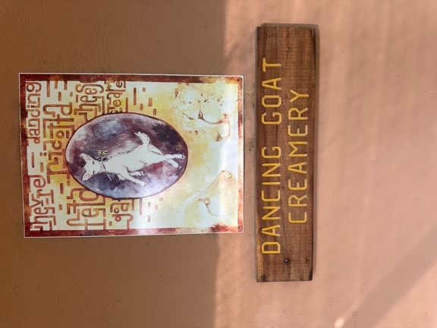

Cheetah Team
We observed four “cheetah runs” (chasing the lure; each morning a different set of three cheetahs). CCF prioritizes safety, ensuring that guests do not get physically close to the cheetahs. Lea, the head keeper, is excellent at her job. We participated in the morning feeding of the cheetahs located 1-5 kilometers away from the center. CCF now has 27 cheetahs, nine of which are candidates for rewilding. Peter and Tigerlily are the oldest cats there at 15 years of age. We saw them in 2012 when they were only 2 years old. They now need special care. Peter’s food is mash as he has digestive problems. They both get supplements in their food and regular intravenous fluid to help them with gastric and urinary problems that tend to affect cheetahs as they get older.

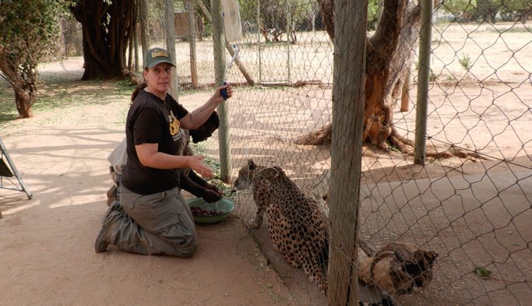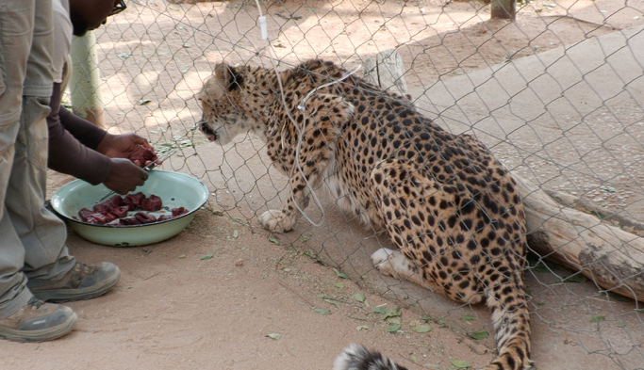

We were fortunate to witness the rewilding of a cheetah that had come into CCF at the end of August and was rewilded during our visit. The timing for release of cheetahs is determined by the needs of the cheetah (and relevant farmers/landowners) and the agreement of the government, as the latter provides the permits for returning a cheetah to the wild. The CCF team worked with the farmer who reported the cheetah as a potential threat and requested CCF's help. After retrieving the cheetah, CCF ensured that returning it to the wild was accompanied by collaring. This will allow CCF to alert the farmer should the cheetah return to his farm. These collars are a vital tool for the cheetah team - they last two years and fall off automatically from the cheetah. They can then be retrieved.
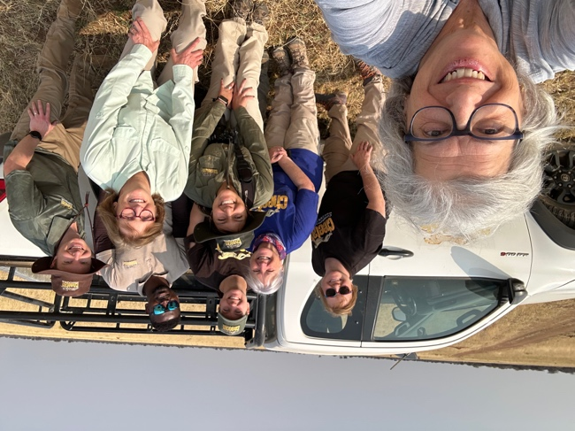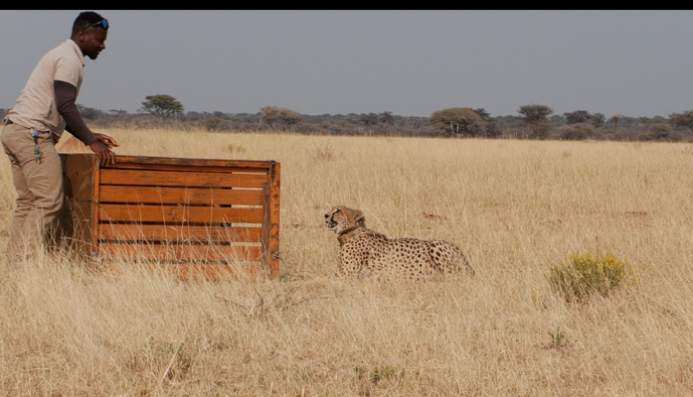

Veterinary Clinic
CCF’s veterinary clinic is a crucial resource, playing a vital role in the health of all the animals at CCF, including cheetahs, livestock guarding dogs, scat detection dogs, and livestock. The clinic is staffed by Dr. Anne Shiimi, a licensed veterinarian in Namibia, Dr. Anahi Hildago, who will soon sit for the Namibia boards, and Panduleni, a veterinary technician. This clinic provides real-life experience for interns and features two spaces for working on animals, as well as an x-ray room.
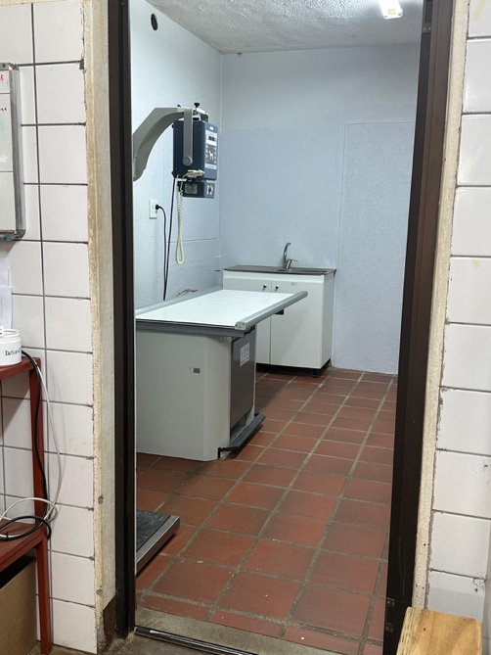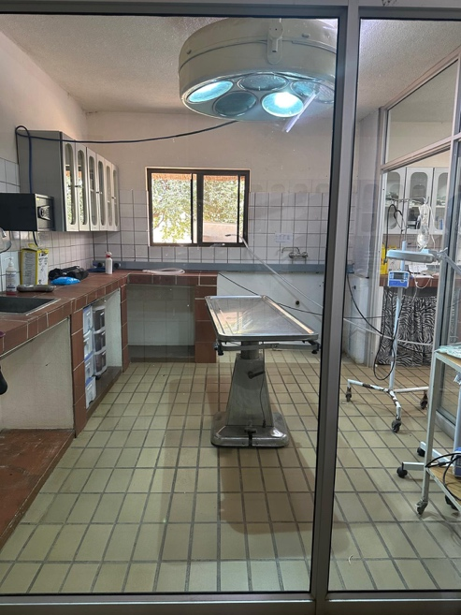
We observed the use of a blood analysis machine funded by the Alan and Patricia Koval Foundation. These machines have significantly improved the clinic's capabilities, allowing veterinarians to run tests in-house and obtain immediate results. This advancement has enabled many animals to start treatments immediately after checking blood results during anesthesia. Previously, samples had to be sent to a local laboratory, taking 1-3 days for delivery and an additional 2-3 weeks for results, delaying medical decisions and treatments.

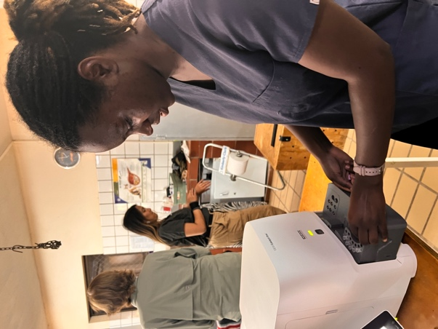

Every cheetah at CCF, whether residing there permanently or temporarily, undergoes a thorough workup to ensure their vitals are good and to collect various tissue samples for the genetics lab. Regular procedures include dental work, treatment for broken bones, internal issues, and chronic disease relief.
During our visit, we observed the team addressing a young cub's gastrointestinal issues. The cub, along with its mother and two siblings, had been surrendered by a farmer.
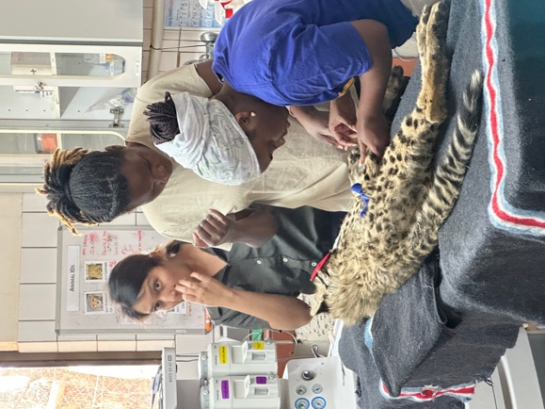
We also witnessed the treatment of a livestock guarding dog that had been severely injured in a baboon attack at a farm. The dog was retrieved from the farmer and underwent a four-hour surgery and is expected to take 3-4 months to fully recover.
Since 2019, CCF has been a key partner in rabies and zoonotic disease control, especially in collaboration with local government and communities to vaccinate stray dogs and reduce the risk of rabies transmission to both humans and wildlife. Over 10,000 rabies vaccinations have been provided.

Genetics Lab
The Genetics Lab at CCF is a state-of-the-art facility equipped with one of only three genetic sequencing machines in Namibia. This lab conducts cutting-edge research on various aspects of cheetah genetics and collaborates with partners worldwide. The highly skilled staff and interns analyze scat, blood, and other tissue samples to gather vital information that addresses multiple issues, such as identifying predators, geo-locating cheetahs, and tackling various medical and ecological concerns.
The lab's equipment is of the highest quality, featuring the most up-to-date diagnostic capabilities. The area was immaculate.
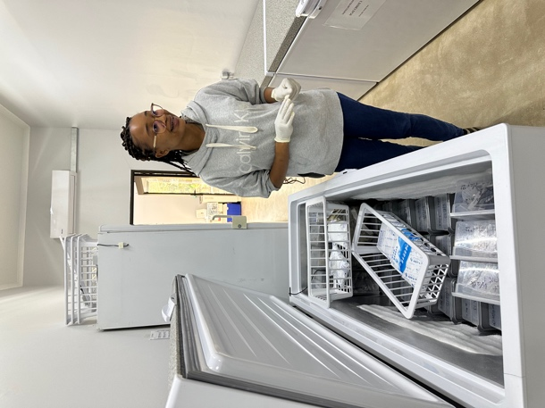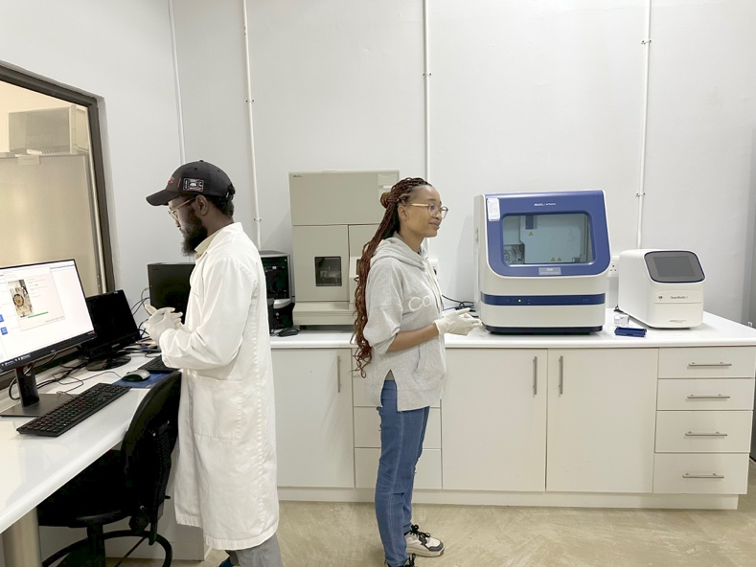

Scat Dog
We joined a group of tourists for a presentation from team member Ruusa and the scat dog Mena. She explained the role of the scat dog program and how these dogs are selected and trained to retrieve scat samples from the vast lands surrounding CCF. These samples are very important for gaining insights into the movement of cheetahs without the need for direct sightings or captures. Tracking cheetah movement and habitat use helps predict conflict areas with farmers. This allows for targeted conflict mitigation strategies, like deploying LGD in high-risk areas.
In some instances, the scat reveals what the cheetah has eaten, which is essential for identifying whether any cheetahs have preyed on livestock animals on neighboring lands. This information helps with the farmer education program.

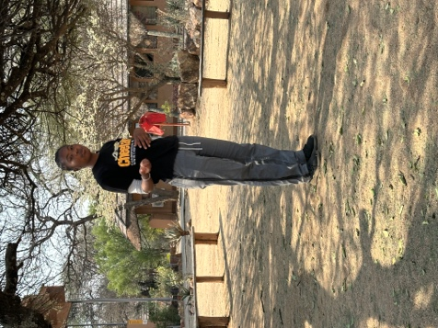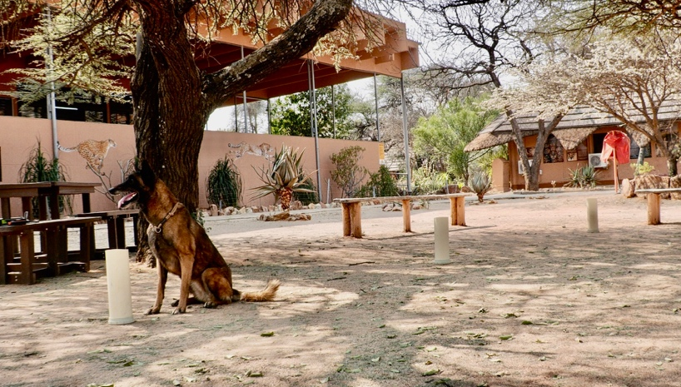

Ecology Team
We me Dr. Robin Cook (right of picture), the new manager of the Ecology Team. Dr. Cook brings extensive experience from South Africa, where he worked with elephants and other wildlife. We discussed the progress of the B2Gold project, which focuses on addressing human-wildlife conflict. Robin mentioned that there is a planned next phase for this field project which would include the area between CCF and Etosha, forming a triangle which would be adjacent to B2Gold mine. We are planning to approach Clive Johnson/B2Gold for continued funding on this expanded research.
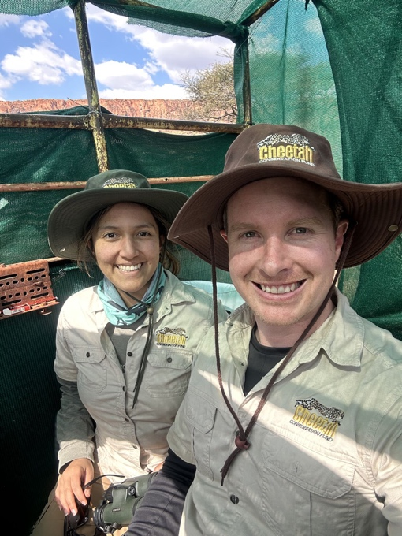
One of Robin’s team members, Ester Kalenga, provided an excellent overview of the work the ecology team does. This includes research on various ecological issues and conducting regular wildlife counts. The team is also expanding its use of camera traps to monitor wildlife on CCF and adjacent properties, as well as to support work in communal lands.
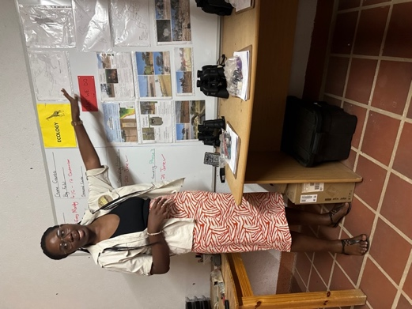
Education Outreach and Internships
We met with Shannon Kendjai, the manager of the education program. Shannon oversees the Student Interns, including the Vanier interns, and leads the education outreach initiatives, such as the Future Conservationists of Africa (FCA). We also had a productive discussion with Ignatius David, Senior Educator, about CCF’s education outreach to learners (primary and secondary level).
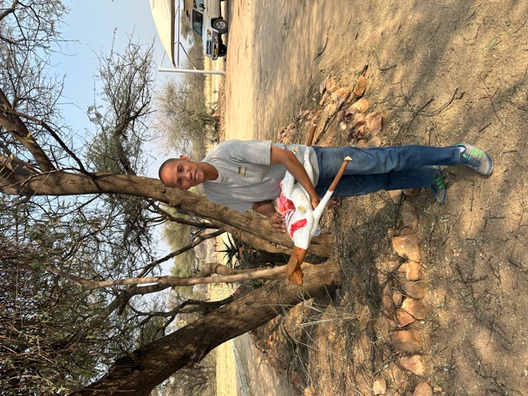
The FCA program is well-established, with 13,076 students, 347 teachers, and 65 schools participating in 2025 alone. Ignatius shared the new teacher’s guide with us.
During our week, we observed two school groups visiting CCF for a half-day: a group of very young learners (five years old) and a group of middle school students. Both groups were highly engaged and enthusiastic.
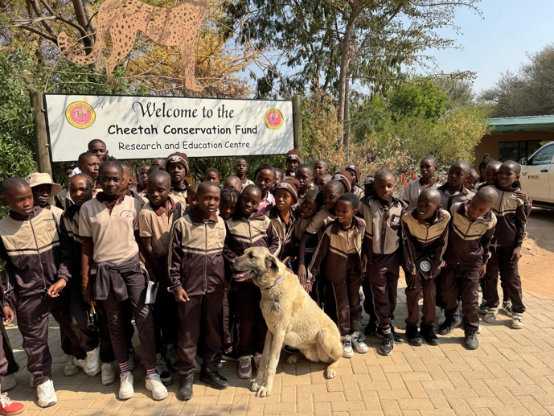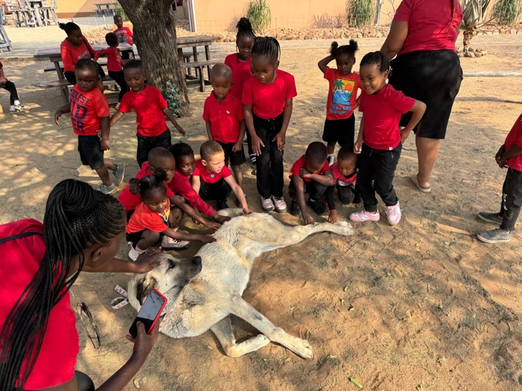

(Note: We did not have discussions focused on the Future Farmers of Africa (FFA) program training. This program is delivered by many staff members at CCF depending on the topic. CCF’s team trains farmers and community members in sustainable land management, conflict mitigation, livestock guarding, and eco-friendly farming practices. Farmers who received conflict mitigation training on better farm practices saw predation reduced by 60%.)

Tourism and Hospitality
The Tourism and Hospitality department at CCF has grown significantly and now contributes 30 percent to CCF Namibia's revenues. Cheetah View Lodge, with its six multi-person units (and expanding), offers excellent accommodation for guests wishing to stay overnight or for multiple nights. The lodge features a pleasant restaurant that provides meals twice a day, while lunches are available at the café in the main part of the CCF campus.
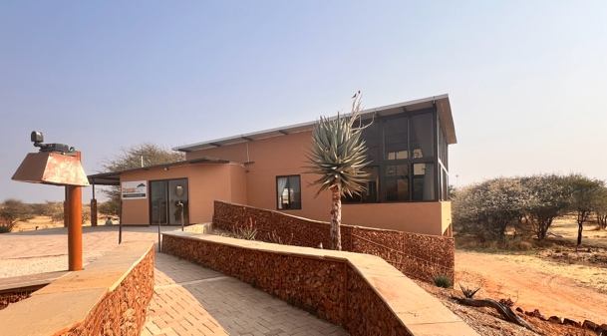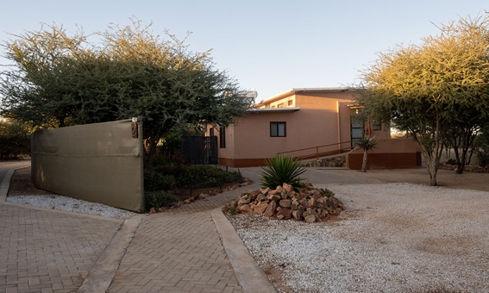
The department also manages tourism offerings, including the daily cheetah run, cheetah feeding, LGD/model farm and nature drives. The three tour guides are very guest-oriented and possess extensive knowledge of CCF’s operations and the surrounding wildlife. We were fortunate to take part in two early evening nature drives into the CCF Reserve, where we observed a good variety of wildlife: multiple numbers of giraffe, steenbok, ostrich, kori bustard, kudu, eland, hartebeest, jackal and more.
We observed multiple tour groups from various countries, including Canada, the US, and several European nations. For instance, G Adventures, a Canadian company, was there with a group of ten people guided by a South African. There appear to be good opportunities to promote CCF's lodging and tourism capacity among our Canadian supporters.
We discussed with Bianca Jacobs, the manager of Tourism and Hospitality, the opportunity to have Canadian groups visit CCF. She mentioned that she is working with local tour operators to include CCF in a three-night stay. We expressed our interest in promoting this program to our supporters once it is finalized.

Facilities, including pens
CCF has built and renovated several animal pens located near the CCF Centre. These pens provide space for cheetahs that are permanent residents at CCF, as well as those needing temporary housing away from people. For example, during our visit, a mother and three cubs were successfully retrieved from a farmer dealing with human-wildlife conflict and were placed in quarantine. One of the cubs was quite physically stressed, making the right kind of pen vital. Some of the larger pens, including the Species Survival Pens (SSP), have been funded by the Gray Foundation.
Further from the CCF campus, major work is underway on a 200-hectare piece of land to create large enclosures (going from one to five hectares each) to house permanent resident cheetahs. These large pens have been mandated by the Namibian government. There have been delays in completing them, but they are expected to be finished by year-end. The Gray Foundation has funded $50,000 for this project.

Bushblok Operation
During our visit, we had the opportunity to tour the Biomass Technology Demonstration Centre, which is conveniently located near the CCF Centre. This facility showcases the best practices for bush harvesting and explores the various potential uses of biomass. The Centre operates on a demonstration level, illustrating the entire process of converting harvested bush into customer-ready products. This includes everything from initial bush clearing to the final production of biomass products.
The Biomass Technology Demonstration Centre continues to attract funding for research and development, particularly from Northern European countries. This financial support enables the Centre to innovate and improve its processes continually. The Centre's efforts are crucial in promoting sustainable land management and providing eco-friendly solutions to bush encroachment, which is a significant environmental challenge in Namibia.
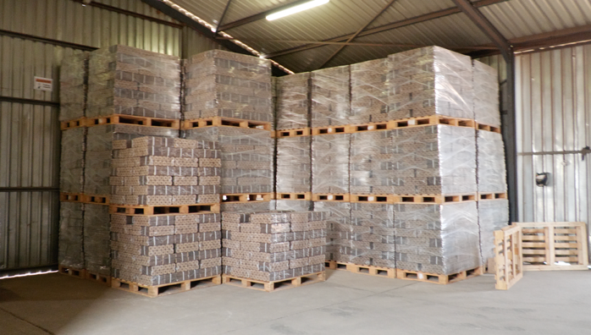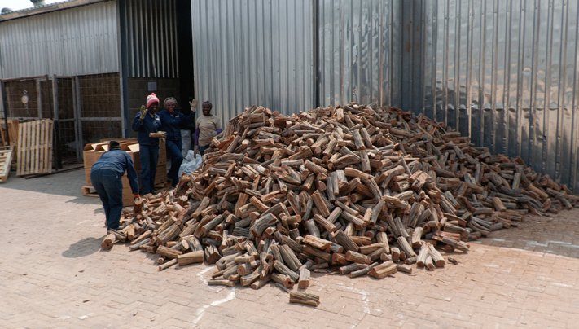

In addition to the technical aspects, the Centre also plays a vital role in educating local communities and stakeholders about the benefits of biomass utilization. By demonstrating the economic and environmental advantages of converting bush into valuable products, the Centre helps to foster a more sustainable and prosperous future for the region.

Visitors and Delegations
In addition to the many visitors, including tourists, school learners, and more, CCF welcomes businesspeople, government officials, and numerous international representatives. These visits provide an excellent opportunity for CCF to showcase its work and foster collaborations.
On our final day, CCF was hosting a delegation from the Environment and Climate Change Ministry of Somaliland, led by the newly appointed minister, Abdillahi Jaamac Osman. The delegation spent a day and a half at CCF to learn about their initiatives in Namibia and explore the potential for implementing similar programs in Somaliland. This visit was a significant step towards building a collaborative relationship between CCF and the Somaliland government, aiming to address common environmental challenges and promote wildlife conservation efforts in both regions.
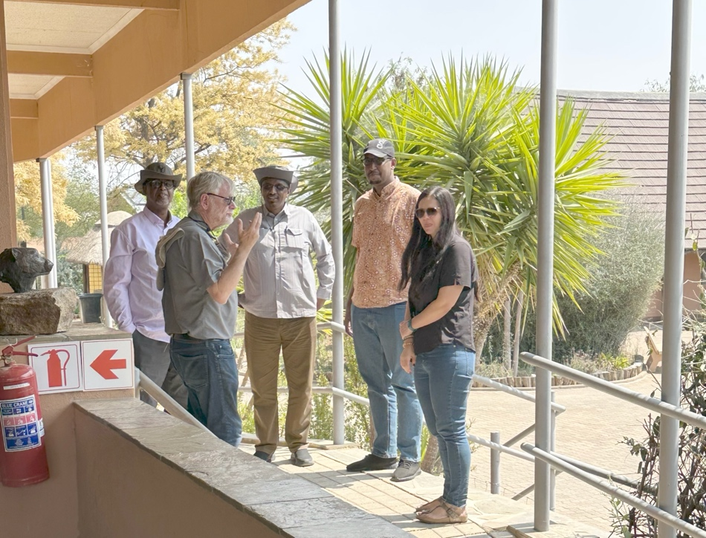

During their visit, the delegation toured various facilities, including the veterinary clinic, genetics lab, and the model farm. They were particularly interested in the Livestock Guarding Dog Program and the innovative approaches CCF employs to mitigate human-wildlife conflict. The delegation also participated in discussions with CCF staff to understand the operational aspects of CCF programs and explore opportunities for knowledge exchange and capacity building.

Conclusion
Our visit to the Cheetah Conservation Fund (CCF) in Namibia highlighted the significant progress made since Carolyn's last visit in 2016. Meeting with each program manager and obtaining an up-to-date view of their work has been invaluable. This experience will greatly enhance our communications in Canada and enrich our presentations in key cities. By sharing these firsthand insights, we can provide more credibility to our messaging and strengthen our donation and grant requests.
During our visit, we were able to observe the various programs and initiatives funded by our Canadian donors. Each of these programs plays a crucial role in CCF's mission to conserve cheetahs and their habitats. The dedication and expertise of the staff were evident in every interaction, and it was clear that their work is making a significant impact.
We also had the opportunity to see the tangible results of our contributions, such as the animal pens funded by the Gray Family Foundation and the lab equipment provided by the Koval Foundation. These investments have directly supported CCF's efforts to protect and rehabilitate cheetahs, as well as to conduct vital research and education programs.
Furthermore, our discussions with the managers of the Student Intern program and the Education Outreach initiatives have provided us with a deeper understanding of how these programs are shaping the next generation of conservationists.
Overall, our visit has reinforced the importance of our support for CCF and has provided us with a wealth of information to share with our supporters in Canada. By highlighting the progress and successes of CCF, we can continue to build strong relationships with our donors and secure the funding needed to sustain and expand these critical conservation efforts.

